SonicSEO.com Social Media Services
Date: February 19, 2021
Version: Draft 02
Client: Duke City Recovery Toolbox
Social Media Platforms: Facebook
Time Period for Online Publication: March

Messages:

Facebook- 31 2
Blog 7

Please read the following copy and let us know if you would like to change anything. If we do not hear from you before February 26th, we will assume your implied consent and post the following messages to your social media accounts starting on March 1st.

Facebook- 31
- Did you know there are various types of drug addiction therapy? [Link to Blog]
- Today is World Teen Mental Wellness Day. You can raise awareness by helping teens practice self-care with exercising, meditating, listening to music and more. #WorldTeenMentalWellnessDay
- Pandemic-fueled alcohol abuse creates wave of hospitalizations for liver disease. https://www.modernhealthcare.com/safety-quality/pandemic-fueled-alcohol-abuse-creates-wave-hospitalizations-liver-disease
- Parents Who Host, Lose the Most: Do not Be a Party to Teenage Drinking. https://www.bernco.gov/community-services/parents-who-host-lose-the-most.aspx
- In case you missed our new hours! https://www.dukecityrecovery.com/ 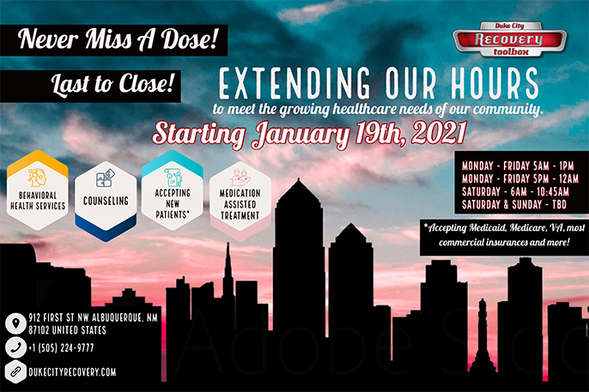
- 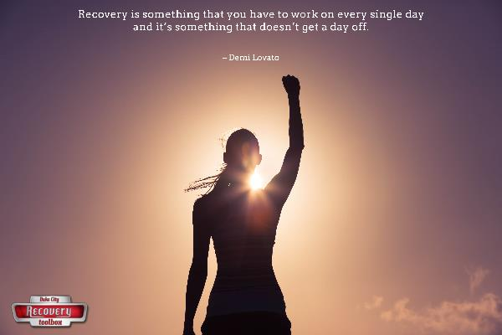
- Learn about substance abuse in women and how to treat it and prevent it. https://www.healthywomen.org/condition/substance-abuse
- 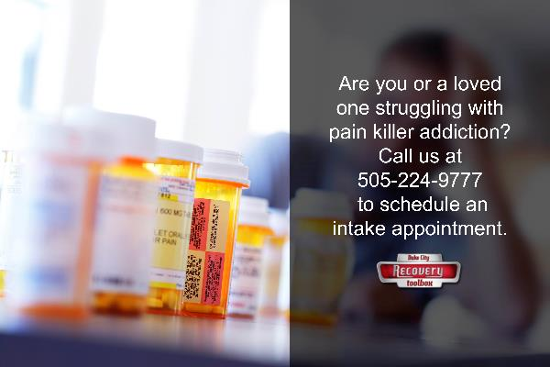
- Finding the right treatment for drug addiction can be difficult. Learn about different treatments and how they work. [Link to Blog]
- Are you interested in joining our Bible Study? All faiths are welcome! Learn more. https://www.dukecityrecovery.com/groups/
- Individuals who decide to quit cold turkey often do not prepare for life after dependence or drug addiction. This sets them up for relapse because they are still in situations or circumstances that do not support a drug-free life. https://www.dukecityrecovery.com/risks/cold-turkey/
- The abuse of any substance, whether prescription pain killer, illicit drug, or alcohol, increases the mother’s risk for a miscarriage. Learn more here. https://www.dukecityrecovery.com/risks/prenatal/
- Prevent an overdose by getting the proper training to administer Narcan on your friend or family member struggling with addiction. https://www.dukecityrecovery.com/narcan-training/
- Here are terms to use and avoid when talking about addiction. https://www.drugabuse.gov/nidamed-medical-health-professionals/health-professions-education/words-matter-terms-to-use-avoid-when-talking-about-addiction
- 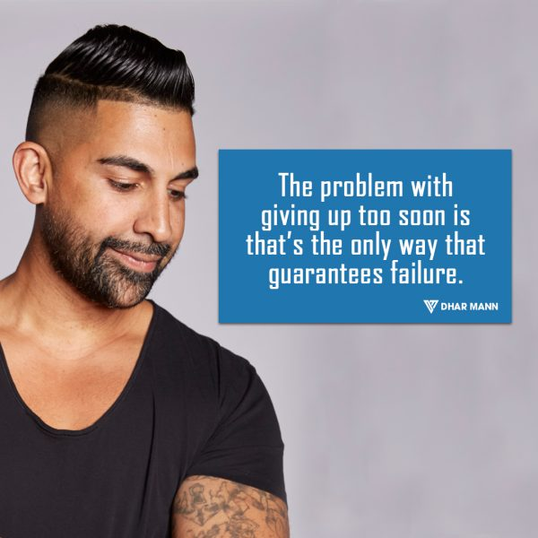https://www.dharmann.com/dhar-mann-quotes/
- Duke City Recovery Toolbox in Albuquerque, NM provides various types of drug addiction treatment. Learn more [Link to Blog]
- Participants often have mental health issues, and at DCRT, we treat more than addiction. https://www.dukecityrecovery.com/therapy/
- FACT or MYTH? The lower the dose of methadone, the better. https://www.dukecityrecovery.com/treatment/myths-facts/
- Facts and myths about opioid pain medications. https://health.ucdavis.edu/livinghealthy/topic/pain-management/facts-myths-about-pain.html
- 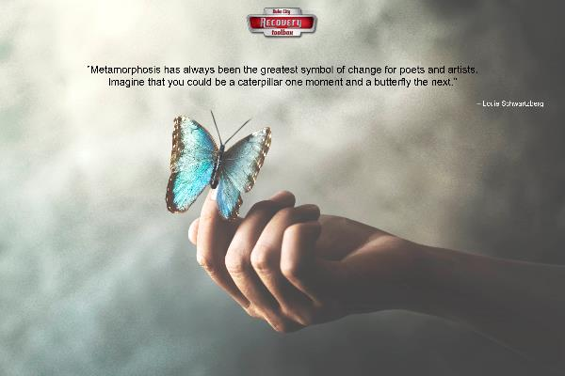
- Check out these top 6 smartphone apps for addiction recovery https://www.rehabs.com/smartphone-apps-for-recovery/
- When you are ready to expand your life, we can help you coordinate with other agencies for help with employment, housing, food, & financial support. https://www.dukecityrecovery.com/recovery/
- Learn about different types of drug addiction treatments offered at DCRT. [Link to Blog]
- Fetal Alcohol Spectrum Disorders: FAQs of Parents & Families. https://www.healthychildren.org/English/health-issues/conditions/chronic/Pages/Fetal-Alcohol-Spectrum-Disorders-FAQs-of-Parents-and-Families.aspx
- Learn how to move through the stages of change to a life free of addiction. Contact us at 505-224-9777 for medication and treatment that works. https://www.dukecityrecovery.com/therapy/stages/
- Meditation is a common practice in addiction recovery because of the benefits it provides. Here are 28 best meditation techniques for beginners to learn. https://positivepsychology.com/meditation-techniques-beginners/
- 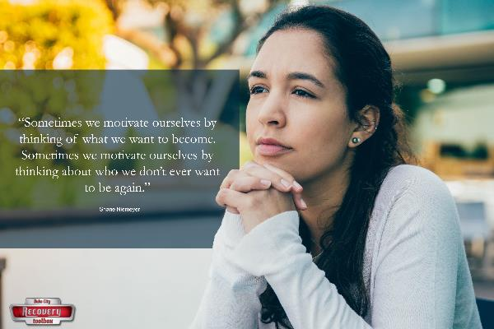
- You know we are an outpatient clinic that offers addiction recovery services and much more, but do you know who runs Duke City Recovery Toolbox? https://www.dukecityrecovery.com/about-us/
- FACT or MYTH? Methadone rots your teeth and gets in your bones. https://www.dukecityrecovery.com/treatment/myths-facts/
- Behavioral therapy is one of the various treatments used for addiction recovery. [Link to Blog]
- 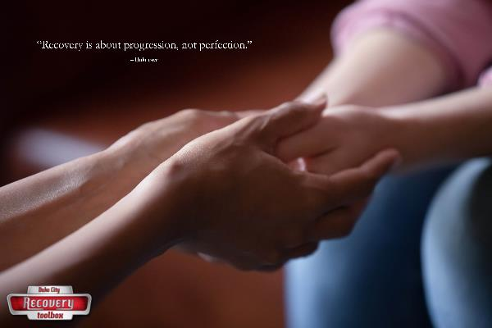

Blog
Meta Description: For successful addiction recovery, you must understand different treatments and how they work. Here are a few common therapies to consider.
Various Types of Drug Addiction Therapy
Drug addiction is a complex problem. What works for another person might not work for you, and vice versa. That’s why there are so many approved treatments available, which gives you a real chance at achieving and maintaining sobriety.
Finding the right treatment can be difficult, especially for those approaching recovery for the first time. The following therapies have proven successful for many people, and one or more may be necessary to help you get a handle on your addiction, and your life.
Behavioral Therapy
Many people use alcohol and other drugs to self-medicate or cope with an underlying mental health issue. These issues range from generalized anxiety to post-traumatic stress disorder. While a person should seek to get their addictive tendencies under control as soon as possible, real gains can’t be made without addressing the underlying problem.
That’s where behavioral therapy comes in. In addition to treating mental health disorders, therapy can also help you develop healthier coping mechanisms for dealing with stress in your life. When you can cope with stress and other issues, you have a better chance at remaining sober in the long-term.
Medication
Medications can be used to stop cravings and prevent uncomfortable withdrawal effects. For example, naltrexone is a medication used to treat alcoholism. It blocks receptors in your brain that respond with pleasure when alcohol is consumed. Suboxone has a similar effect on the brains of people who abuse opiates, such as heroin.
With opiate addiction, there are also medications used to wean people off their drug of choice. This includes methadone, which eases withdrawal symptoms and allows a person to incrementally lower their dose until they no longer need the medication.
Peer Support
While loved ones play an essential role in your recovery, it also helps to spend time with likeminded people, who understand addiction firsthand. This is where peer support comes in.
Peer support specialists are people who’ve successfully completed a recovery program and are now sober. These people are available to talk you through tough times and encourage you to keep going in your sobriety. Because they can empathize with you on a deeper level, they’re a valuable part of the recovery process.
Where to Find Addiction Therapy in Albuquerque
Duke City Recovery Toolbox provides the above treatments and more. We tailor addiction recovery plans to the individual for the best chance of success. We also offer services like medication-assisted treatment, peer support, and behavioral therapy.
Please call (505) 224-9777 to speak with an addiction recovery specialist today. You can also contact us for more information about our treatment center and how we can help you.

